|  |  |
| --- | --- |
| ***the daily grind*** | *The Daily Grind is a cozy coffee shop dedicated to crafting the perfect cup. They offer a serene setting, perfect for parents and friends to catch up or for colleagues to work together. With free Wi-Fi, it's an ideal spot to escape traffic and stay productive.* |

Course:Introduction to Web Development

Group Members:

1. Benjamina Mbaki – JHBCOD000340710
2. Blessing Nwegape – 1195222
3. Checy Funwi - 1195270
4. Daniel Gbaderm - 0606185880089
5. Khensani Mathye – 0601011060089
6. Ntandoyenkosi Nxumalo – 0302275209088
7. Peterson Junior Boitumelo Headger – 0403155398080
8. Sibusiso Seyiwa – 0601155252088
9. Vanessa Ngum – AA562618

Submission Date: 20 June 2025

**1.Project overview**

**THE DAILY GRIND**

***The Daily Grind is a cozy coffee shop that provides an inviting atmosphere for coffee lovers and those seeking a space to relax, work, or socialize. Our website aims to enhance our customers’ experience by offering essential features such as an online menu, order-ahead service, event information, and a loyalty program. The website also reflects our commitment to quality coffee, sustainability, and community engagement.***

**Team Members and Contributors:**

|  |  |
| --- | --- |
| **GROUP MEMBERS:** | **CONTRIBUTIONS:** |
| 1.VANESSA | Goals and objectives and contacts pages |
| 2. DANIEL | CSS implementation across all pages |
| 3. CHECY | Menu page and order online page & CSS implementation across the about us, contact us, goals, login and order online pages |
| 4. KHENSANI | Documentation coordination on Project Overview |
| 5.NTANDOYENKOSI | Documentation coordination on Website Structure and HTML Elements used |
| 6. BENJAMINA | Documentation coordination on CSS implementation and HTML Elements used |
| 7. PETERSON | Customer Reviews and Store location pages as well as adding CSS on location pages |
| 8. SBUSISO | Home page |
| 9. BLESSING | About us and team members pages |

**GOALS AND OBJECTIVES OF THE WEBSITE:**

*Goal 1*: Enhance customer experience through online services.

•*Objective 1.1:* Provide an easy-to-navigate online menu with detailed descriptions and pricing.

•*Objective 1.2*: Implement an order-ahead feature to streamline the pickup process.

•Goal 2: Promote community engagement and events.

•*Objective 2.1:* Create a calendar section to inform customers about upcoming events, tastings, and workshops.

•*Objective 2.2:* Develop a loyalty program that rewards customers for their visits and purchases.

•*Goal 3:* Highlight sustainability and quality sourcing.

•*Objective 3.1:* Share information about the origin of our coffee beans and our commitment to ethical sourcing.

•*Objective 3.2:* Educate customers on sustainable practices, such as reducing waste and using reusable cups.

**By achieving these goals, “The Daily Grind” aims to create a strong online presence, foster customer loyalty, and build a thriving community around the love of coffee.**

**2. Website Structure**

**Site Map**

Our website consists of 6 main pages connected through a consistent navigation bar:

• Homepage (index.html)

• Menu (menu.html)

• Locations (locations.html)

• About Us (about.html)

• The Team (team.html)

• Contact (contact.html)

**Page Descriptions**

**Homepage (index.html)** The homepage serves as the main entry point to our website. It features:

• A welcoming text “Welcome to The Daily Grind”

• Images of different coffees to give the viewer different options

• A navigation bar featuring the shop’s logo

• A quick access to “order now”

• Variety of option to choose from on the navigation bar(login, Contact about us and etc.)

**Menu Page (menu.html)** This page displays all products offered by the coffee shop, organized into categories:

• Coffee drinks

• Iced tea and tea

• Pastries and snacks

• Side desserts

Each item includes a description, price, and whether it's available for takeout.

**Locations Page (locations.html)** The locations page provides information about all three branches of the coffee shop:

• Address information

• Images of each location

**About Us Page (about.html)** This page tells the story of the coffee shop:

• Company history

• Founder of the company

**The Team (team.html)** Showcasing the staff members:

• All the workers and their description

• Images of the workers

**Contact Page (contact.html)** Allows customers to get in touch through:

• A contact form (non-functional as per requirements)

• Email and phone contact information

• Address

**Navigation Explanation**

All pages feature a white navigation bar at the top of the page with links to all main sections. The shop’s logo is at the left side. The navigation bar is used to make it easier for people to use the website effectively.

**3. HTML Elements Used**

**Key HTML Elements**

**Content and Media Elements**

• <h1>Welcome to the Daily Grind

<h2>Our Menu

<h3>Contact Us

<h4>About Us

<h5>the Daily Grind

<h6>Team Members

<h7>Our Goals

<h8>Customer Reviews

<h9>Main Store

• <p>: For paragraphs of meet the founder, company history, our goals and team members

• <img>: Used for images of coffee drinks

• <figure> and <figcaption>: Not Used

• <table>: Not used

• <ul> and <ol>: Not used

**Form Elements (on Contact Page)**

• <form>: Container for the Contact form, Login and order now

• <input>: Various input types (text, email, tel, checkbox, submit)

• <textarea>: For message input

• <label>: Used on Login, Contact and order online

• <select> and <option>: For dropdown selection of coffee type, size and dessert as well as number of coffees

• <button>: Submit button, Cancel button, Login button, Order now, Locations: Rosebank, Port Elizabeth and Cape Town

**Screenshot Examples**

**Homepage:** 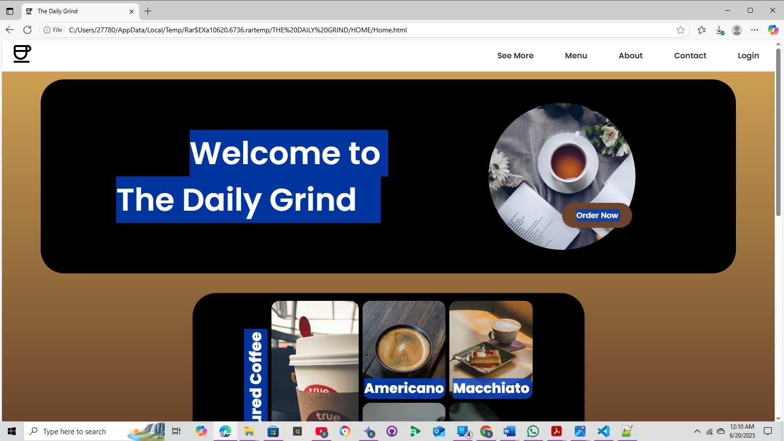

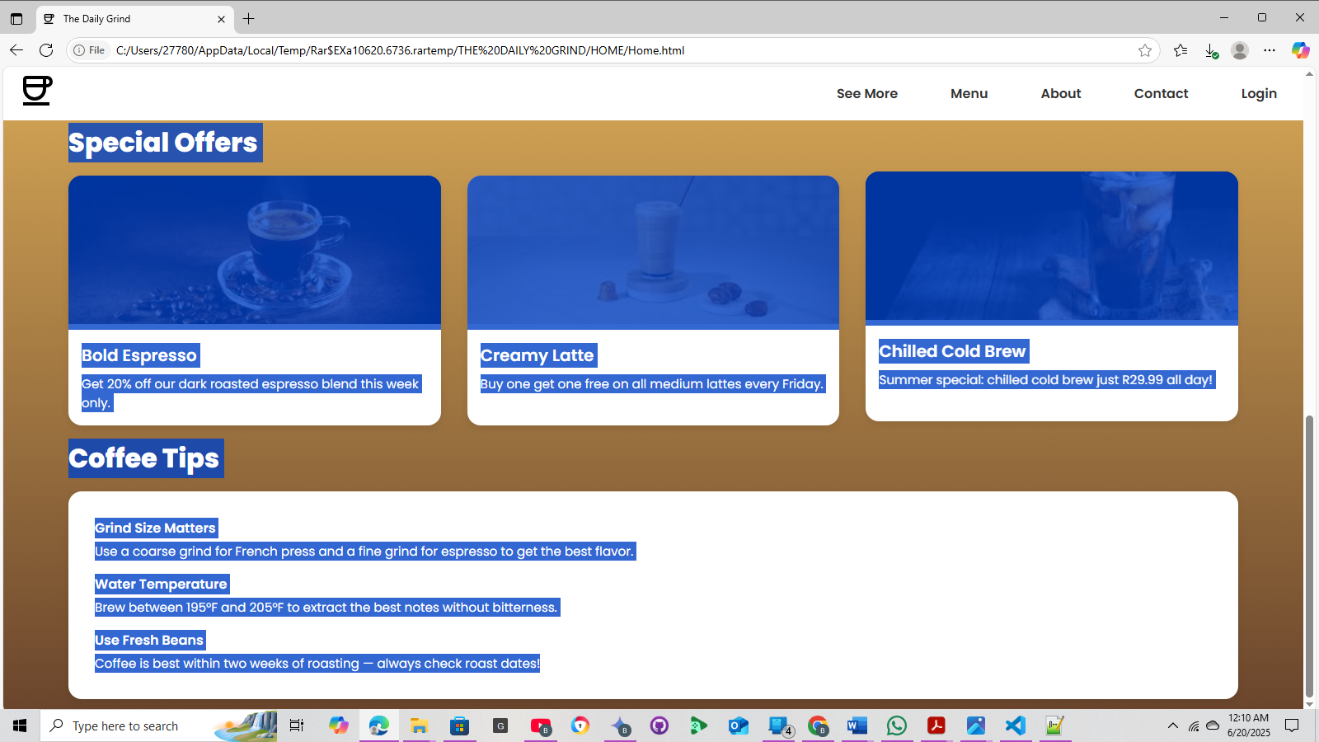

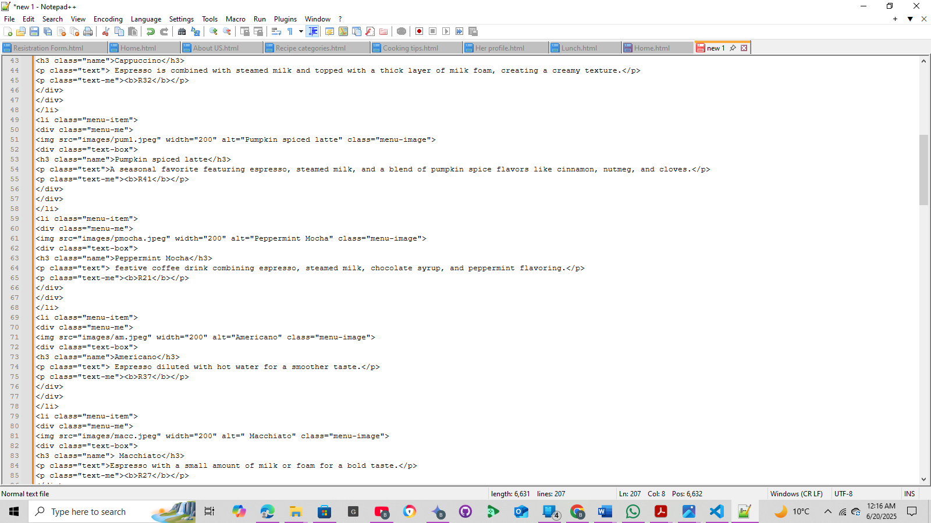

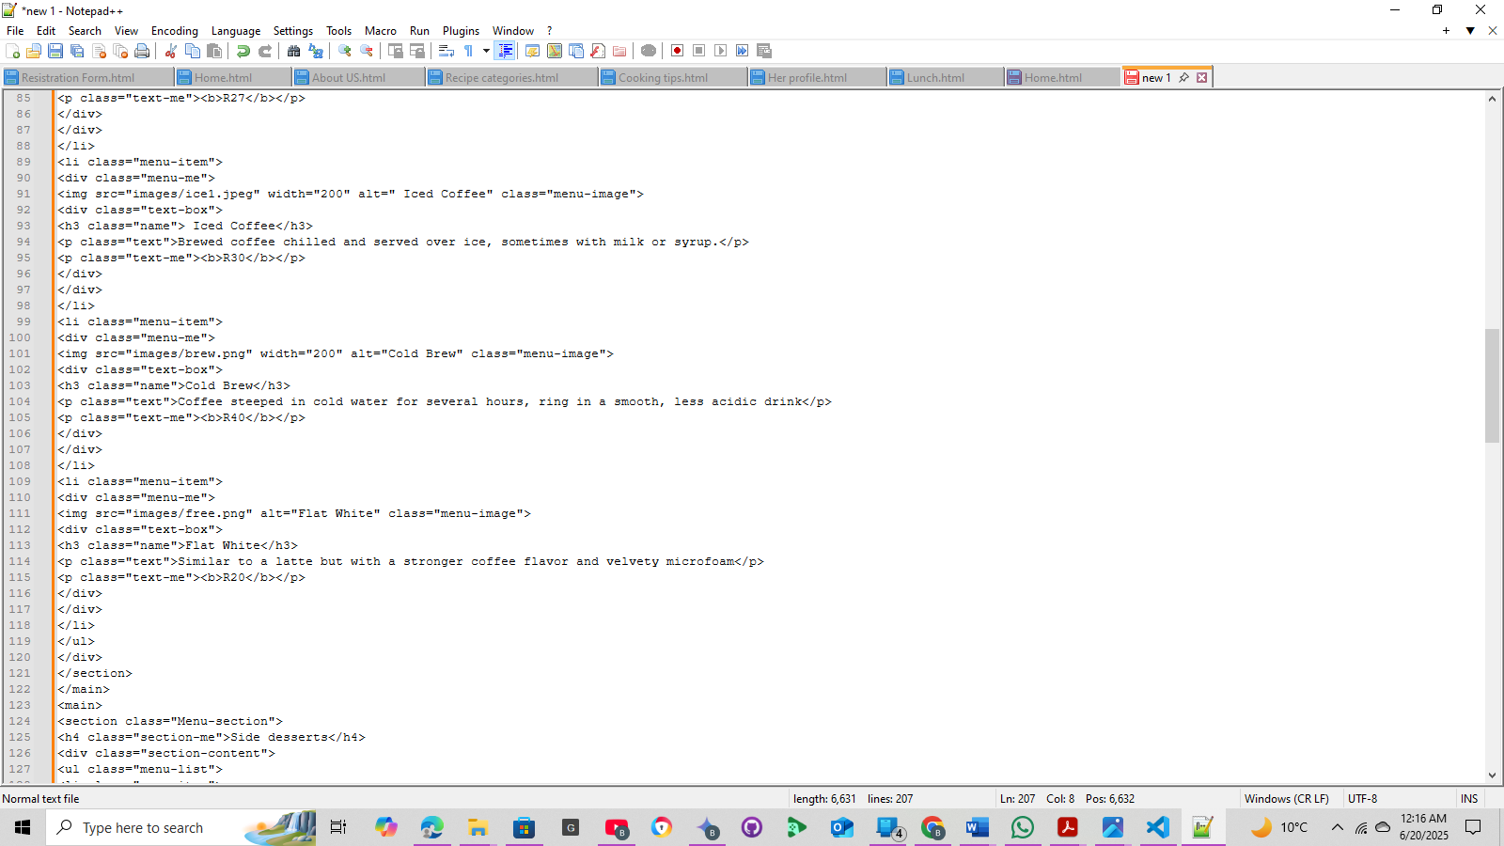

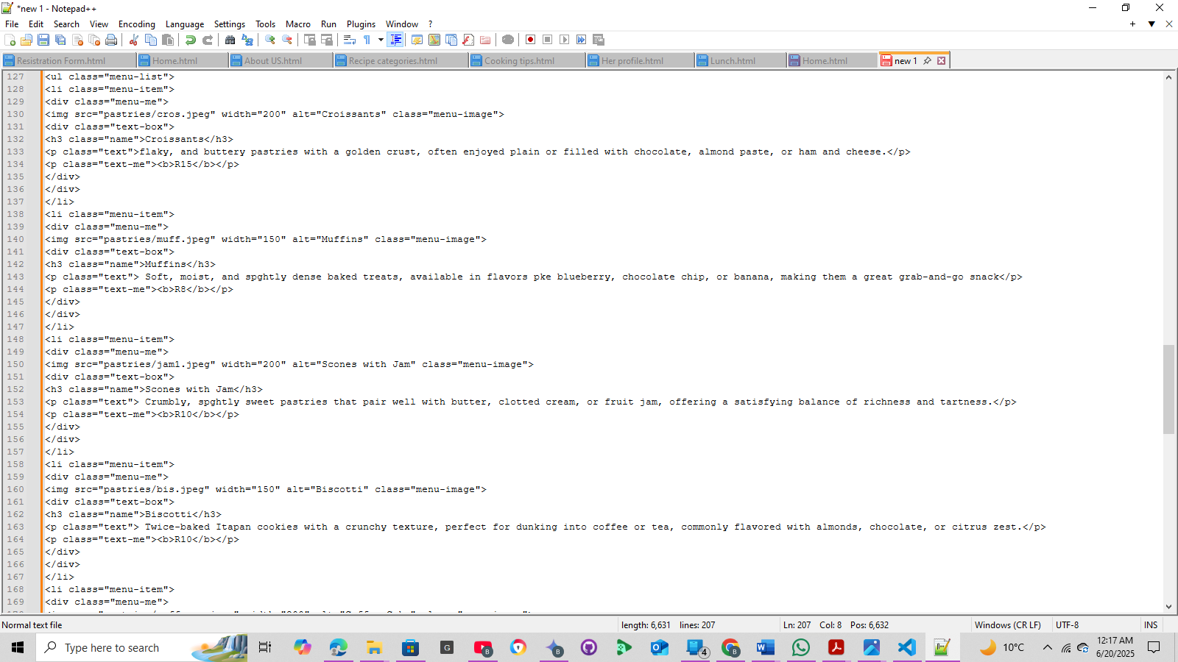

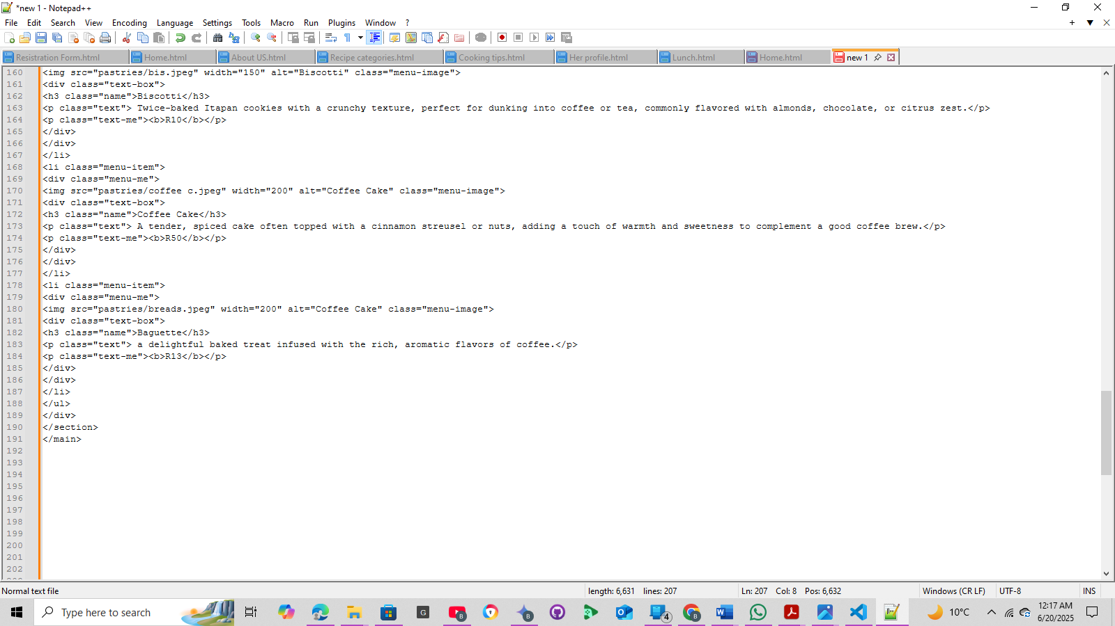

**4. CSS Implementation**

**CSS Properties Researched and Applied**

**Layout Properties:**

• display: Used flex display for navigation bar at the top of the page and card layouts

• margin and padding: Applied to give shape and spacing

• width and max-width: Used for sizing and contrast of the website

• position: Applied navigation bar at top of the page

**Typography Properties:**

• font-family: Selected "Poppins” and “Sans-serif” from Google Lens

• font-size: Different sizes were used to match the text of the website

• line-height: Set to 1.5 to improve readability on text

• text-align: Used to left-align texts, headings and right-align navigation bar

**Color and Visual Properties:**

• color: White, Brown, Black, Red, Gray

• background-color: #ae794b (brown)

• border and border-radius: Applied on different sections

• box-shadow: Applied to give contrast to the website

**Color Scheme and Design Choices**

These colors work together to create a visually appealing and harmonious color scheme:

• Primary color: #FFF (White)

• Secondary color: #D6A756 (Brown)

• Accent color: #E33 (Red)

• Background colors: #ae794b (brown) and #6a452c (brown)

• Text colors: #FFF (white) and (brown)

The Daily Grind aims to create a visual, appealing, inviting, and functional design that effectively communicates the brand’s identity and values. By considering factors such as contrast, warmth, accent colors, brand identity, design trends and accessibility.

**5. References and Resources**

**HTML and CSS Learning Resources**

• W3Schools HTML Tutorial: https://www.w3schools.com/html/

• Codeacademy: https://www.codecademy.com/learn/learn-css

•web.dev: https://web.dev/learn/html

• YouTube

**Image and Content Sources**

• Logo: thedailygrind.com, Pexel.com, Unplash.com and Flaticon

• Hero image: Google.com

• Coffee menu item images: Pexels.com, Flaticon.com, Unplash.com

• Icons: Google fonts

All images used are download from various websites, licensed under Flaticon, or Pexel.com.

**Appendix: GitHub Repository**

Our project is available at: https://github.com/Benjamina-Mbaki/The-Daily-Grind

The repository contains all HTML files, CSS files, images, and documentation.